NHS

Interim Report

30-01-2026

Executive Summary
- Problem in plain language
- Recommended solution
- Expected impact (clinical, operational)

1. Background
Osteoarthritis is a leading cause of disability worldwide, currently affecting approximately 250 million people, with its prevalence rising due to an aging and increasingly obese population. In the UK, an estimated one in ten have symptomatically clinically diagnosed osteoarthritis. Roughly 200,000 hip and knee replacement procedures are conducted annually in England where osteoarthritis is indicated as the main reason. Traditional medical management is typically reactive, and effective diagnosis can be complex as osteoarthritis is known to be linked to multimorbidities. However, there is a critical shift toward individual patient care and shared decision-making (SDM), which seeks to improve care and reduce costs by integrating clinical evidence with patient preferences. To support this approach, accurate prediction models are necessary to assess surgical outcomes and further advance precision medicine.
Multiple stakeholders are affected by the outcomes of these orthopedic procedures. Patients undergo surgery primarily to improve their health-related quality of life, yet they require highly accurate, individualised predictions to set realistic expectations and avoid dissatisfaction. Clinicians need data-driven tools to complement their professional expertise, enabling them to inform patients more precisely about the likely success of a procedure. Furthermore, organizations such as the National Health Service (NHS) are affected because they utilize patient-reported outcome measures (PROMs) to monitor the quality of care and manage the significant direct and indirect socioeconomic costs associated with treating osteoarthritis.

2. Problem Statement
Traditional clinical management fails to effectively use precision medicine to tailor treatments to specific patient needs. These management gaps result in devastating clinical consequences, including persistent pain and disability for 10-20 % of patients one year post-surgery, which leads to widespread patient dissatisfaction and diminished health-related quality of life. Ultimately, the absence of individualized, data-driven prediction models prevents the realization of precision medicine, incurring substantial socioeconomic costs through high medical expenditures and indirect burdens such as work productivity loss.
In England, private hip and knee replacements typically cost between £12,000 and £18,000, with averages around £14,000. Moreover, these interventions put further pressure on the health system by claiming much needed hospital bed capacity.These costs do not include the aforementioned work productivity loss for society.

3. Project Scope & Value
Project Scope
This data science project aims to deploy a machine-learning tool that predicts binary postoperative improvement following surgery. Utilizing a multi-year NHS dataset of over X observations, we will develop a machine learning model that can outperform traditional linear models in predictive accuracy and serves as a reliable second opinion for clinicians as they make a decision with each individual patient regarding the likelihood of a successful hip or knee replacement. The project provides a framework for integrating individualized outcome estimations into routine clinical practice. Equally important, it allows clinicians and patients to decide together on whether an operation is most likely to provide the most benefit for each individual case, or whether alternative non-invasive care is advised.
Limitations
The machine learning model developed in this study is intended to supplement clinical expertise and should primarily serve as a "second opinion" to support SDM after a clinician has formulated an initial assessment. A critical limitation of the project is that the provided NHS dataset exclusively includes observations from patients who actually underwent surgery, meaning the models were trained on a filtered, non-representative subset of the general population. Because the study lacks data on patients who did not undergo surgical intervention, it was impossible to model health trajectories for those who did not undergo surgery. Consequently, the model cannot identify individuals who might have benefited from surgery but did not receive it. Ultimately, the tool provides a real-world benchmark for likely outcomes, but its use is restricted to informing the conversation between a clinician and a patient who is already considering a procedure.
DAPS Diagram
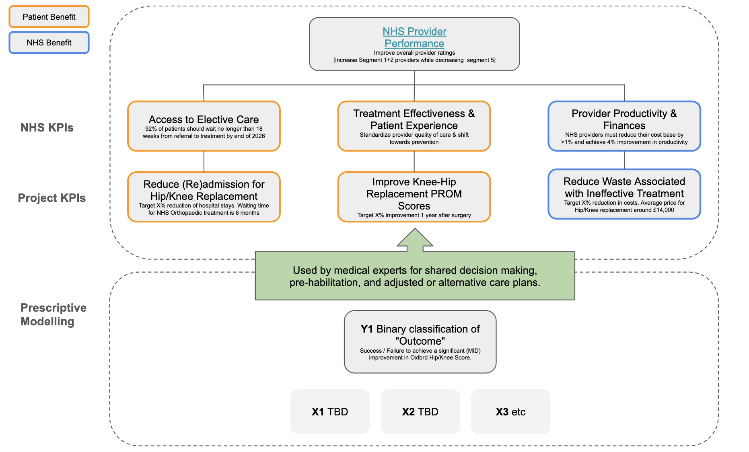
This DAPS diagram translates high-level institutional goals down to actionable interventions. At its foundation, the prescriptive model will utilize binary classification to predict outcomes (based on Oxford Hip/Knee scores) and other data variables (X1,X2,X3) to inform SDM and personalized care plans. These clinical insights are designed to support clinicians advising patients and to ultimately achieve a set of KPIs, such as reducing readmissions, improving PROM scores, and minimizing provider costs from ineffective treatments. These improvements scale up to meet broader NHS KPIs, aiming to reduce elective care wait times to under 18 weeks, standardizing the quality of care and improving overall financial productivity, thereby enhancing NHS provider performance ratings and patient satisfaction. More detail about each layer of the DAPS diagram is provided below.

NHS Provider Performance:
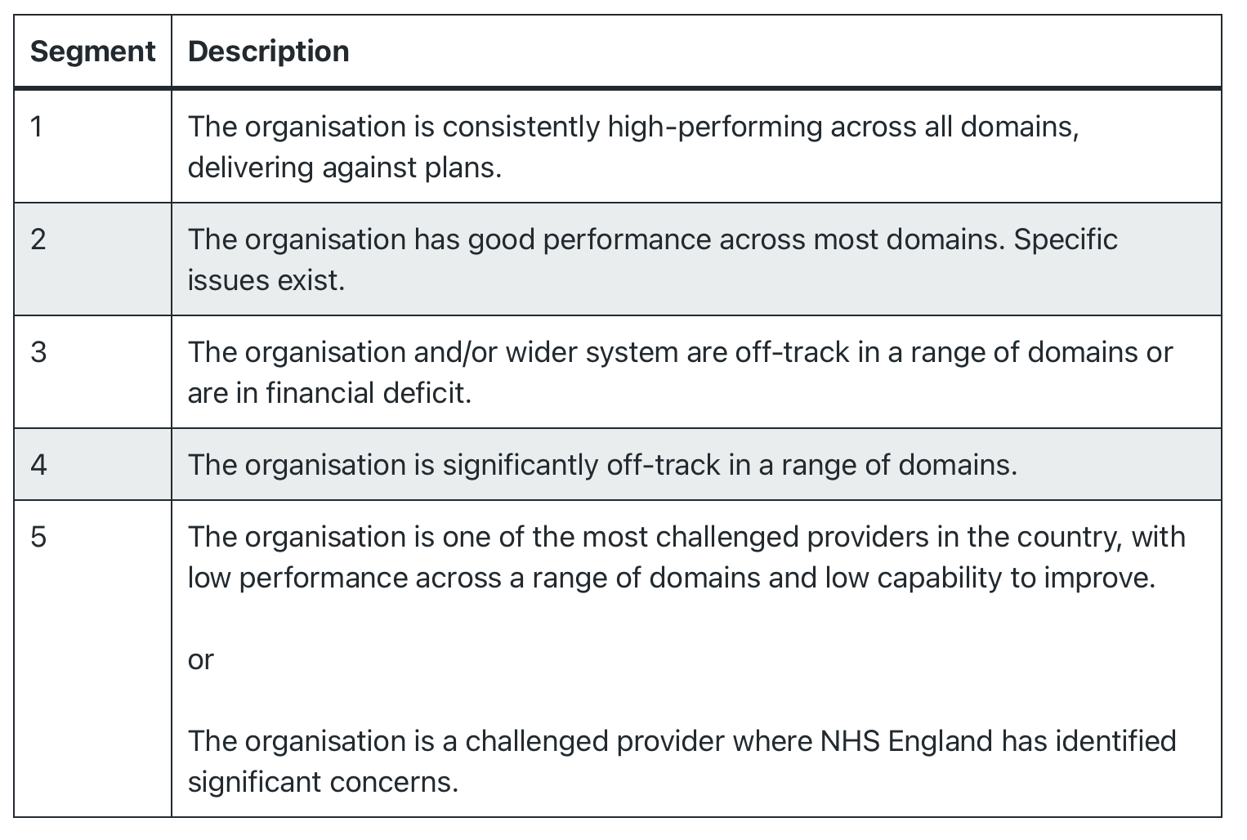
Under the NHS Oversight Framework for 2025/26, provider segmentation is a data-driven process that categorizes NHS organisations into five distinct levels based on their performance against national priorities—such as elective recovery, urgent and emergency care —and their overall financial health. This system uses an organisational delivery score (1–4) derived from five core domains (Access, Effectiveness, Safety, People, and Finance), which is then adjusted by a financial override that prevents any provider in deficit from being placed higher than Segment 3. The segments are defined as follows:

NHS KPIs: System-Level Mandates
These represent the broad targets set by the central NHS to ensure organizational stability and access to care:
- Access to Elective Care: The target is for 92% of patients to wait no longer than 18 weeks from referral to treatment by the end of 2026. This is a critical recovery target following the backlogs of previous years.
- Treatment Effectiveness & Patient Experience: The focus is on standardizing the quality of care across different providers while shifting the clinical focus toward preventative measures.
- Provider Productivity & Finances: Organizations are tasked with a dual financial goal: reducing their base cost by at least 1% while simultaneously achieving a 4% improvement in productivity.

Project KPIs: Orthopedic-Specific Metrics
These KPIs translate systemic goals into measurable outcomes for hip and knee replacement pathways:
- Reduce (Re)admission: While the primary goal is reducing readmissions, the specification notes that the current average waiting time for NHS orthopaedic treatment in England is approximately six months, which this project seeks to mitigate.
- Improve PROM Scores: Success is defined by a target X% improvement in PROMs exactly one year post-surgery.
- Reduce Waste: This financial KPI focuses on the "average price" for a hip or knee replacement, which typically ranges around £14,000. The goal is to eliminate "ineffective treatment" costs that fall within or exceed this range.

Business Value
Our main goal is to reduce the amount of clinically ineffective surgeries for hip or knee joint replacements by predicting which patients will report pain and disability one year after surgery. This enables a range of advantages:
- Proactive identification of patients who will likely not benefit from this surgery before surgery takes place.
- Informed clinical decision-making to potentially avoid unnecessary procedures
- Patients avoid an invasive procedure that is less likely to be clinically effective for them and can be directed toward alternative treatments that do have a higher chance of success.
- Significant cost efficiencies for the healthcare system by reducing clinically ineffective surgeries.
- More efficient use of healthcare resources. Decreasing the amount of clinically ineffective surgeries frees up capacity for patients who will genuinely benefit. This consequently will improve wait times.
- Hospital and surgical departments improve their outcome statistics and reputation.
- Reducing low value care aligns with medical ethics: do no harm.
- Standardization: The predictive tool creates more consistency in decisions, this standardization will reduce unwarranted variation between clinicians.

Process flow visualization
This section explains how the Machine Learning Model (ML model) fits in the current process. It outlines the planned workflow that clarifies how and where the ML model is applied in the decision-making process. It explains when each outcome is used, who is responsible for interpreting it, and how these insights contribute to more informed and deliberate choices.

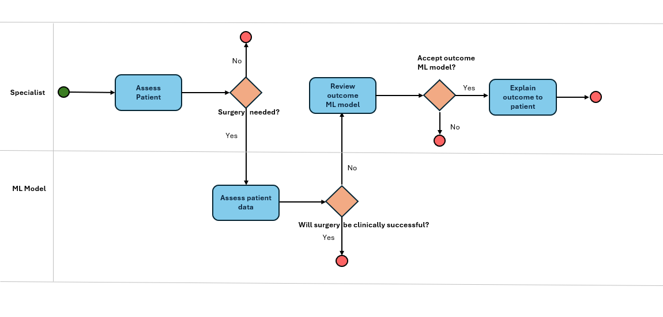
Assess patient: The specialist assesses whether the patient requires knee or hip replacement surgery. If the decision is no, the process ends. If yes, the next step involves the ML model.
Assess patient data: For patients recommended for surgery, the ML model analyses the patient’s data and predicts the likelihood of clinical success. The model either supports or does not support the specialist’s decision.
Review outcome ML model: If the model does not support the specialist’s decision, the specialist reviews the model’s explanation to understand the reasoning behind the prediction. This step is essential, as the specialist must fully understand why the model disagrees before deciding whether to accept or reject the model’s outcome.
Explain outcome to patient: When the specialist accepts the model’s outcome, they translate the model’s reasoning into patient-friendly language. This step relies on explainability, as the patient must understand the basis for the recommendation and how the model contributed to the decision.

The next phase requires a series of choices regarding scoping and the operationalization of the model outcome, as well as what the model should aim to excel in.
- you already indicate you will model a binary outcome metric. I agree with that approach, and please add a brief explanation in your report as to why you choose a binary outcome metric
- the lack of a definition of the outcome is now blocking further progress, so let's make sure we arrive at a choice in our next meeting. You emailed considering both EQ VAS and OHR. Which one would be preferred from the perspective of the patient, the doctor and the data scientist? If you share your ideas, backed up with data if appropriate, then I am sure we will reach a conclusion
- also, based on the use case, which performance metric (e.g. recall, sensitivity, AUC, precision) do you propose the model will optimize?
- In our meeting we can then discuss what value to aim for, for this metric.
- Lastly, it will be useful to start exploring the data, and propose a series of scoping choices: do you want to cover both knees and hips in this project, or focus on one? And do you find any small groups in terms of demographics that might be better to leave out of the analysis?

4. Methodology
- Data sources used
- Data is appropriate and reliable
- How insights are generated
- Providers scores only
5. Validation & Performance Metrics
- How success was measured
- Key results
- Limitations and known risks

6. Recommended Solution
- Present solution
- How it supports SDM
- Where it fits into existing workflows

7. Implementation Plan

Clinical Integration

Clinical Safety & Ethics

8. Appendix
- Data Selection Process
- Feature selection
- Model architecture
- Full performance metrics

9. Sources

HS Oversight Framework 2025/26: https://www.england.nhs.uk/long-read/nhs-oversight-framework-2025-26/

Operational Planning Guidance:
https://www.england.nhs.uk/long-read/2025-26-priorities-and-operational-planning-guidance/

Reforming Elective Care:
https://www.england.nhs.uk/long-read/reforming-elective-care-for-patients/

Feedback Interim Report Joran: 13-02-2026
Scoping Choices
Hip and/or Knee: Focus on hip first and then test if it can be generalized for knee. Note: One group has higher rate of improving which makes it easier to find a clear model outcome.
Groups: Decide if we want to focus on only specific groups (gender? age, etc)
Providers: Focus on providers dataset only, there could be overlap with CCG.
Data Preparation
Be careful to only remove rows where you know upfront that information is missing (e.g. gender). Be sure to consider if the data determines the generalizability of the model. If an outcome is missing, you won’t know it when you run the model.
Can we combine EQ-VAS & OHR?
Surgery directly impacts OHR. Could eventually impact EQ-VAS. Adding EQ-VAS adds noise, so the focus could be more on OHR. Describe if there is a correlation between EQ-VAS and OHR.
There is more variation in how OHR changes versus EQ-VAS. More difficult to find features that explain difference. Need to identify minimal differences (define the percentage)?
Metrics
If we go for numeric outcome (OHS/OK score) - we will end up with too wide a range. Therefore, determine a critical threshold within the scale to determine if outcome is Y/N. Otherwise you give a probability to doctors and they will end up interpreting it incorrectly/differently.
Consider if we have unbalanced data and what to do with it.
AUROC is more generic, but outcome of model is less generic. AUROC you have to pick an area under the curve.
Training data is everyone that had surgery. Select a group of people where we are sure that they are not benefitting (not benefitting = true positives). Note: “Positive” is that someone needs a surgery. In the context of clinicians and patients, we only are looking for incremental improvement (instead of flagging up 20-30% of patients that do/do not benefit from surgery, could be better to only identify the 5%).
AIM: Maximizing the TP (=patients not benefitting) = precision
Agreed Approach: Model based on AUROC (positives and negatives). Need to identify a point on the curve (at what probability do I classify people as positive or negative). Then, draw a precision recall curve and focus on the precision of 80% of patients that won't benefit. Of all the positives you may even only identify 5%.
Need to ensure we always link back to the actual process to make the model effective.

